**Screen #2.5 During the game**

**Tone: Friendly :)**

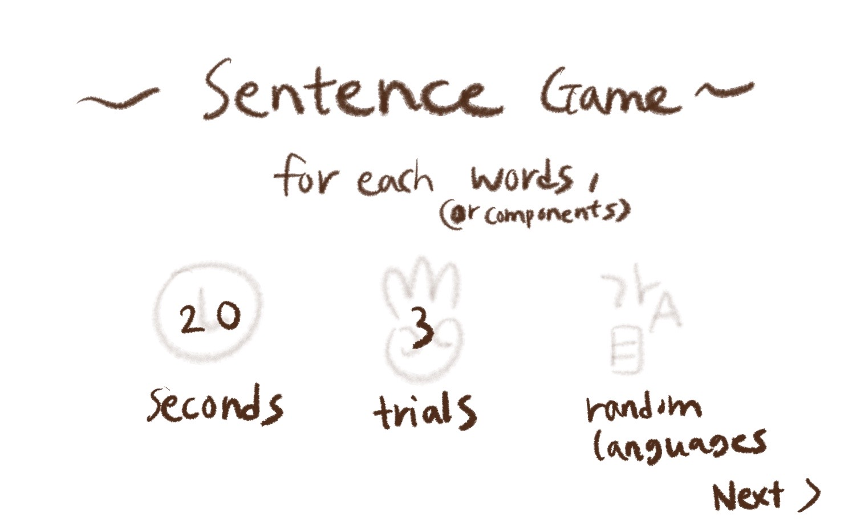

(The screen will be like this!!)

For each word, (OR components) ☺ ***Your translation here:***

Trials (OR CHANCES) ☺ ***Your translation here:***

Seconds (AS TIME) ☺ ***Your translation here:***

Random Languages ☺ ***Your translation here:***

___________________________________________

What do you think it means? (OR Can you guess it?)

☺ ***Your translation here:***

Type… (AS A ‘TYPE HERE’)

☺ ***Your translation here:***

You got it right!

☺ ***Your translation here:***

For the first trial, you wrote:

For the second trial, you wrote:

For the third trial, you wrote:

☺ ***Your translation here:***

The answer was ___ .

☺ ***Your translation here:***

next >>

(THIS IS A BUTTON FOR THE NEXT GAME)

☺ ***Your translation here:***

You were so close!

(IF THE PLAYER DIDN’T GET THE ANSWER)

☺ ***Your translation here:***

HOORAY!

You finished the game.

((OR)) That’s the end of the game.

(IT’S OKAY IF ‘HOORAY’ COULD NOT BE THE SAME IN YOUR LANGUAGE.

EXCITEMENTS LIKE ‘YEY!’ WOULD BE AWESOME.)

☺ ***Your translation here:***

Start Over >>

(RETURNING BUTTON)

☺ ***Your translation here:***

***THATS ALL THANK YOU SO MUCH***